Puru Sai Koushik
2200032991
WEEK-4 spring-rest-handson
REST - Country Web Service

RUN THE ABOVE SPRING APPLICATION
mvn spring-boot:run
see on which server you are working on
here:-8083
the required outputs are seen on this link in the browser or postman
http://localhost:8083/country
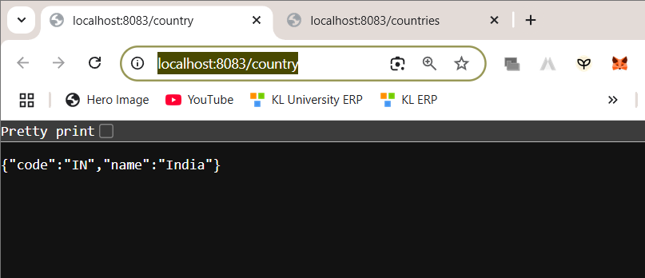
http://localhost:8083/countries
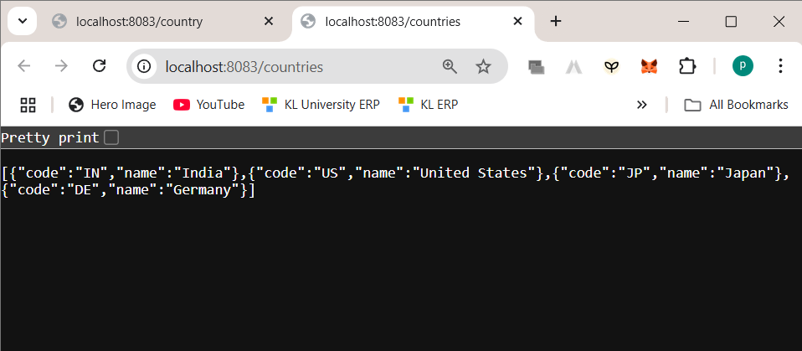

CONTROLLER METHOD

package com.cognizant.spring_learn.controller;

import java.util.List;
import org.springframework.beans.factory.annotation.Autowired;
import org.springframework.context.ApplicationContext;
import org.springframework.web.bind.annotation.GetMapping;
import org.springframework.web.bind.annotation.RequestMapping;
import org.springframework.web.bind.annotation.RestController;

import com.cognizant.spring_learn.model.Country;

@RestController
@RequestMapping
public class CountryController {

@Autowired
private ApplicationContext context;

@RequestMapping("/country")
public Country getCountryIndia() {
return context.getBean("IN", Country.class);
}

@GetMapping("/countries")
public List<Country> getAllCountries() {
return context.getBean("countryList", List.class);
}
}

Country(code="IN", name="India")
{
"code": "IN",
"name": "India"
}

